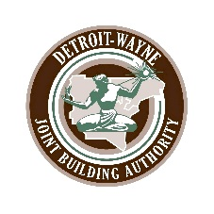
Coleman A. Young Municipal Center
Event Request
Erma Lois Henderson Auditorium Form

The Detroit-Wayne Joint Building Authority thanks you for your interest in reserving the Auditorium at the Coleman A. Young Municipal Center (CAYMC). The Auditorium is reserved for official use on a first come-first serve basis, and must be approved or sponsored by an elected official, appointed department or division head.

Please complete the information below and submit to N.Verstraete and C. Montgomery by fax: 313-309-2400, or emailing to both at: Nancy.Verstraete@hines.com Cynthia_montgomery@dwjba.com or return form directly to Suite 1316 of the CAYMC. You do not receive conformation notification within one (1) week of submission of request please contact the office at: (313) 309-2300
Event Information
Organizer Contact: | Name: Phone: Email:
Event:
Sponsor/Department:
Date of Event:
Start Time/End Time
Estimated Attendance:

Event Requirements
Loading Dock Access | Yes ○ No ○
Freight Elevator Access | Yes ○ No ○
Public Address System | Yes ○ No ○
Tables | Yes ○ No ○ | #:
Chairs | Yes ○ No ○ | #:
*Overtime HVAC (minimum 4 hrs) | Yes ○ No ○ | $300.00/Hr
*Additional Security? (minimum 4 hrs) | Yes ○ No ○ | $ 21.87/Hr | $
*Elevator Tech required? | Yes ○ No ○ | $250.00/Hr | $

Miscellaneous
*Are you providing catering?  If yes, please provide caters information below: | Yes ○ No ○ | (Consumption of food and beverage is limited to the Atrium only, and is not permitted inside the Auditorium.)
Will you be using our portable projector screen or contacting Media Services for a monitor? | Yes ○ No ○ | Explain:
Miscellaneous Request? | Yes ○ No ○
Please acknowledge your acceptance of the terms of this Use Agreement and attached Addendum:

By: ___________________________________
Date: _________________________________

*Please be advised certain items may be billable to your department. Once your request is reviewed, costs will be outlined. Any items determined to be billable will require Department or Division approval prior to scheduling. If approved, the Auditorium will be reserved for your event. Please call us with any questions at 313-309-2300. Thank you.

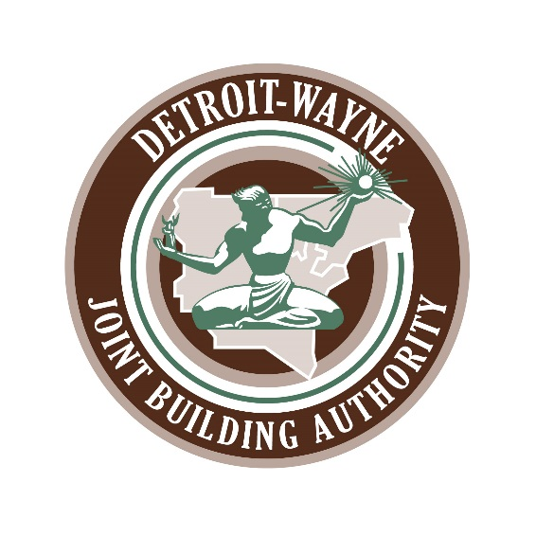

Auditorium Event

Safety First Message

When holding an event in the Erma Lois Henderson Auditorium the Detroit-Wayne Joint Building Authority requires that the event coordinator reminds the audience at the beginning of an event of the following:

- The Detroit-Wayne Joint Building Authority’s Mission Statement provides for the safety of the tenants, employees and visitors at the Coleman A. Young Municipal Center.

- In the event of a building emergency you will hear instructions over the public-address system including the following scenarios:

  - In the event of weather-related conditions please move into the auditorium and sit in the lower section of seats until the “All Clear” is announced.
  - In the event of a power failure or fire, PLEASE EVACUATE IMMEDIATELY via staircase C or D located on either side of the elevators or staircase E. Mobily challenged individuals should go into staircase E and await assistance.
  - In the event of a security breach or active shooter announcement please move into the auditorium and sit in the lower section of seats until law enforcement comes to the area and issues an all clear. DO NOT ATTEMPT TO EVACUATE THE CENTER.

Your cooperation is greatly appreciated.

Coleman A. Young Municipal Center

Post Duties
After Hours Auditorium Events

After Hours Auditorium Events

A Security Officer (SO) must be present at any event which runs past 5:00 PM. This is to ensure the safety of the attendees outside of normal business hours should an incident occur which could result in an emergency or evacuation.

Security Manager will interface with the DWJBA management office in 1316 prior to the event to determine the date, duration and expected crowd size of event. Manager will then assign requisite number of SO’s to be posted at event 30 minutes prior to scheduled start until event is complete and all participants have vacated. SO’s are expected to report to the post with a radio and fully charged battery.

If possible, SO should interface with event organizer prior to the start of event and review the “Safety First Message” attached to this Post Order. It is expected of event organizer to read this message to the attendees at the outset of the program. If they are not willing to read the message, the SO should read the message to ensure attendees are familiar with the protocol.

If Sheriff or Detroit Police have been posted in auditorium, be sure to acknowledge their presence prior to event and maintain contact throughout.

In the event of an alarm calling for evacuation of Center (fire alarm, power outage, etc.), SO will assume the role of Floor Warden, and shall immediately lead the evacuation of the auditorium and atrium areas. Upon hearing the alarm, the SO will:

- Radio Security 2 and acknowledge alarm
- Politely announce to presenter(s) of the event what is occurring and assume control of dais area
- Announce to attendees that the event has been concluded, and all occupants must evacuate immediately using stairwells C, D or E (point to the locations of each stairwell)
- Assess whether any attendees are mobility challenged and help to guide them to the front row of auditorium, then to the stairwell E landing. Radio to Security 2 the number of individuals unable to physically evacuate and verify that Security 2 has contacted EMS and they will be utilizing evac chairs to safely assist immobile individuals down the stairwell.
- Maintain contact with Sheriff and DPD, if applicable
- Do not allow individuals to delay their evacuation, regardless of their position (Judge, City Official, etc.)
- Once auditorium and atrium are vacated, check restrooms and stairwell corridors to determine if all areas are clear and radio Security 2 with status
- If areas are clear, begin descending via stairwell E. If SO encounters anyone evacuating, remain with them until reaching 1st floor. If they are having difficulty, radio Security 2 with location and they will interface with first responders to assist with the evacuation
- Report all clear to Security 2 after reaching 1st Floor

The SO assigned to this post will be required to take a leadership role if an emergency is declared. Therefore, the SO must have the ability to execute the role with confidence. It will be the Security Manager’s responsibility to assign appropriately.

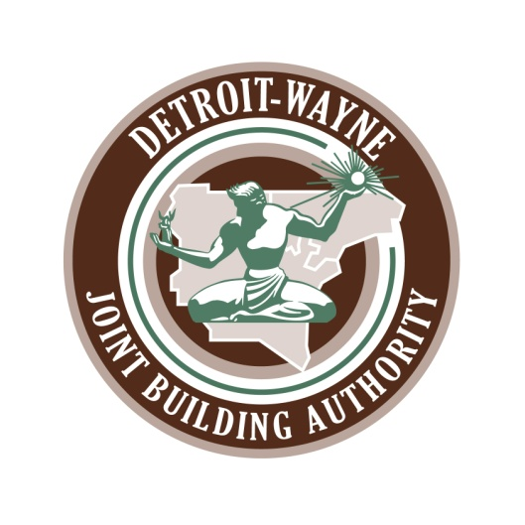

Addendum to Auditorium Request Form: Erma Lois Henderson Auditorium

Requests received for auditorium use can be divided into general categories of use, Internal meetings sponsored by branches of government for their employees and suppliers and public meetings including tax auctions and press conferences.
The revised State of Michigan occupancy standards allows for 50% occupancy effective June 1, 2021 and 100% occupancy effective July 1, 2021.
Considerations: The Sponsor is solely responsible for the following:
- To limit and control the size of the audience and attendees.
- For internal meetings; compliance with facemask requirements.
- For public meetings; facemasks must be worn by all visitors.
- Maintaining social distancing standards.
- In the event of a COVID-19 positive attendee, the sponsor will be responsible for tracing and health follow up with those impacted.
- Read the attached “Safety First Message” at the beginning of the event.

Our Branch of Government/Department is requesting the use of the auditorium and we hereby accept sole responsibility for adherence to the Considerations stipulated above.

SPONSOR:

_________________________

_________________________

Date: ___________________

